|  |
| --- |
| UAS Software Development Project 1 |
| NEST New York |
| Software Design Document |

|  |
| --- |
| Team members:  Daniel Rantala  Joonas Lassila  Teemu Kemppainen  Michael Adebayo |

Contents

1. Introduction 2

1.1 Scope of the Project 2

1.2 Document Overview 2

1.3 Reference Material 2

1.4 Definitions and Acronyms 2

2. User Interface 3

2.1 Site Map 3

2.2 Page Layout 3

2.3 Content Management System design 4

3. Database design 4

4. Client Side SW Design 5

5. Server Side SW Design 6

# Introduction

## Scope of the Project

The main objective of the project is to create a dynamic website for NEST New York, a startup accelerator for Finnish companies that are expanding their business to New York.

The site requirements include a dynamic rental service engine for office space, an event calendar for upcoming events, a styled, professional layout of the web page, customer's sign-up -function and payment transactions for Chase credit cards.

The goal is to create a professional website that eases the process of office renting for NEST New York and collects customer information.

## Document Overview

This document is a short listing and preview of the project, the actual graphical design will be added later. The previews in this document are merely sketches and only cover the functional parts of the website.

## Reference Material

E-mail conversations with NEST New York contact persons Ismo Rantala and Suska Karjalainen throughout the project, starting from April 22th.

## Definitions and Acronyms

Table = SQL –database table, where data from each site/function is located (e.g. customers).

# User Interface

## E:\nest site.jpgSite Map

## Page Layout

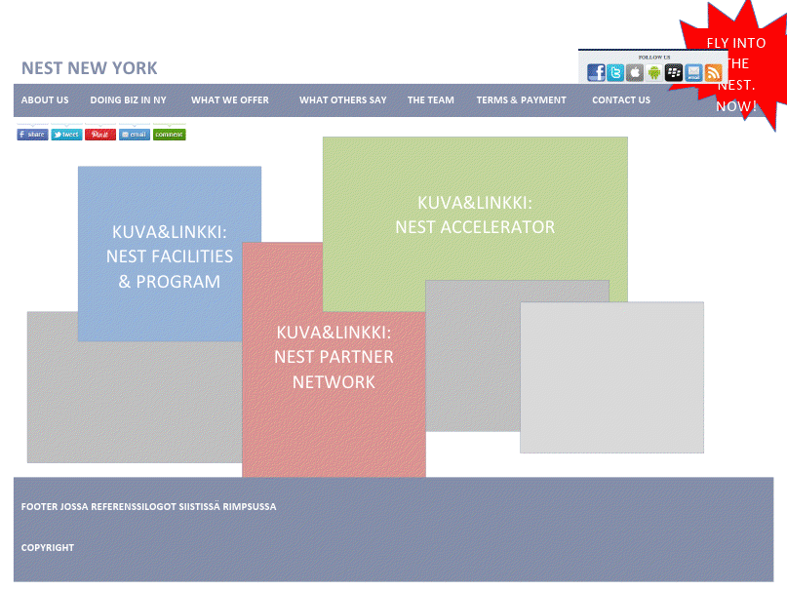

## Content Management System design

In below preview the admin is logged in and is changing The Team –page’s content. He/she can either edit/delete already added team members or add a new one. The site layout sketch is also shown. The layout is a design of the admin control system, and not the visual outcome of the web page’s look.

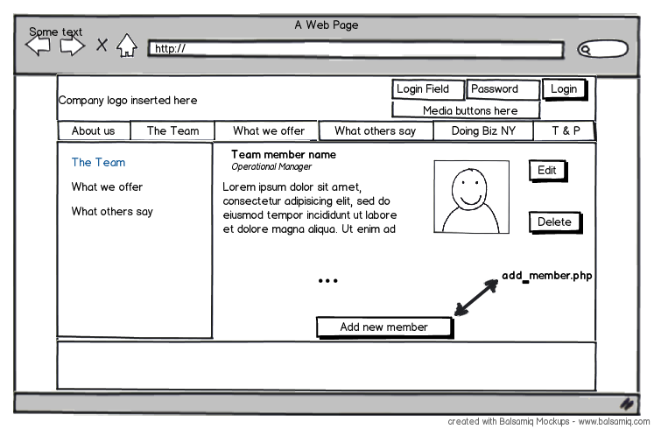

# Database design

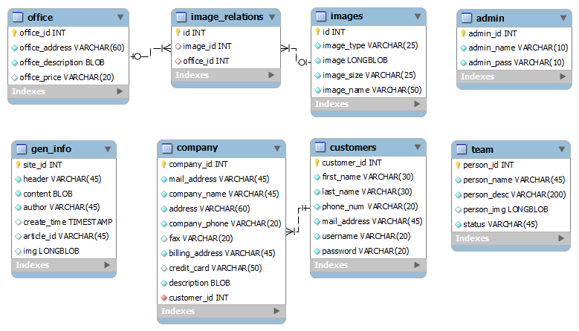

# Client Side SW Design

For this project there is no need for client side programming languages.

# Server Side SW Design

The following .php pages will be needed for the site: